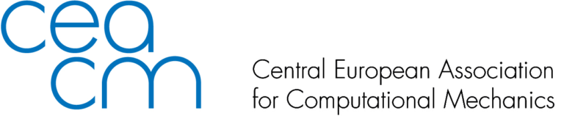

Nomination to CEACM Best Thesis Award 2025
Please send this form by e-mail no later than January 31, 2026 to CEACM Board Members : 'Adnan Ibrahimbegovic' <adnan.ibrahimbegovic@utc.fr>,’Dr. Lógó János’ <logo@ep-mech.me.bme.hu>, 'Bernhard Pichler' <Bernhard.Pichler@tuwien.ac.at>, 'Polach Pavel' <polach@vzuplzen.cz>,'Jože Korelc' <joze.korelc@fgg.uni-lj.si>,'Justín Murín' <justin.murin@stuba.sk>, 'Zdenko Tonković' <zdenko.tonkovic@fsb.hr>

Name of the nominee:

Affiliation:
e-mail:
Name of the award: CEACM Best Thesis
Required items:
- Doctoral thesis
- CV of the candidate
- Support letter from the principal thesis advisor
- 2-3 pages English summary if the language of the doctoral thesis is different than English

